

**CSC1310: lab 9**

**binary search trees**

# Adventure time cast

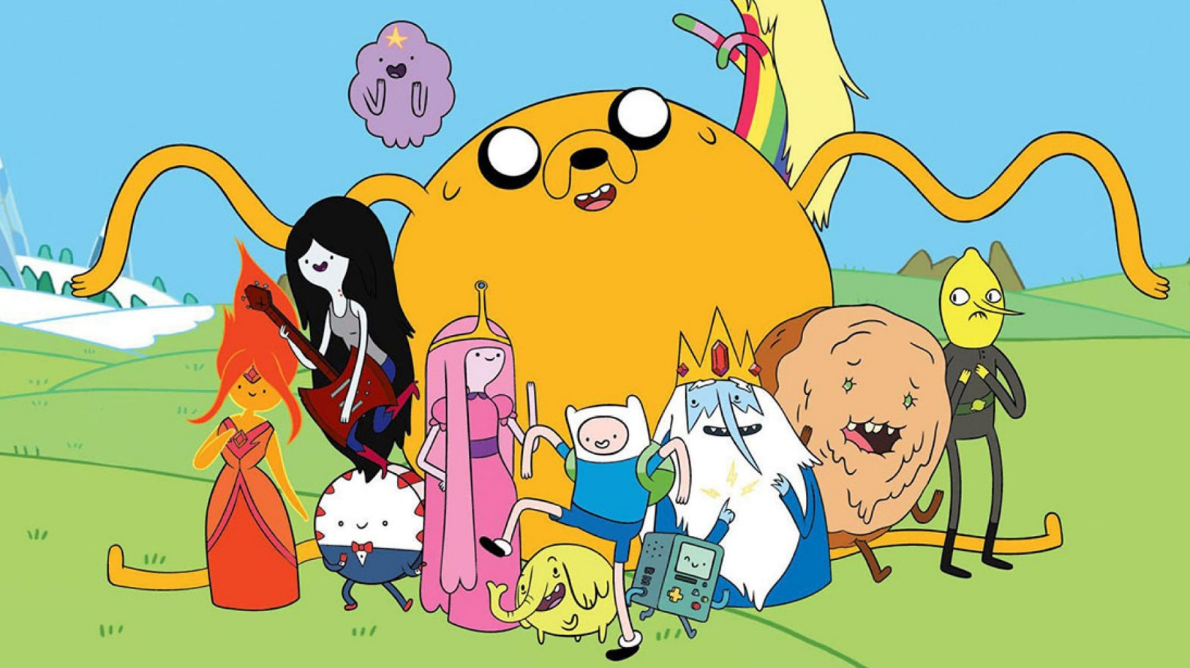

Write your own version of a Binary Tree template class (can hold values of any data type). Name this file **BinaryTree.h**. (more details about this class in the BINARYTREE.H section of this document)

Then, create a class for an Adventure Time cast member called **AT_Cast** that **holds a cast member’s cast** **ID** and their **name**. Name this file **AT_Cast.h**. (more details about this class in the AT_CAST.H section of this document)

Next, use the **provided driver** which creates a binary tree where the nodes hold an object of the AT_Cast class. The nodes **should be sorted on the CAST ID number**. The driver will print out the cast (sorted by cast ID number) in three different ways – **in-order traversal, pre-order traversal, and then post-order traversal**.

# BinaryTree.h

This should be a template class which contains the following private & public members:

## Private attributes & functions

* TreeNode **struct** containing **a value of the template type, a pointer to the left TreeNode and a pointer to the right TreeNode­­­­­­­**
* **A pointer to the root TreeNode**
* Private functions:
  + **Insert**
  + **destroySubTree**
  + **displayInOrder**
  + **displayPreOrder**
  + **displayPostOrder**

## Public Functions

* Constructor
* Destructor (which should call destroySubTree)
* insertNode (which should call the insert function)
* displayInOrder (should call the displayInOrder private function)
* displayPreOrder (should call the displayPreOrder private function)
* displayPostOrder (should call the displayPostOrder private function)

# AT_Cast.h

**AT_Cast class should hold the following (private) Adventure Time information:**

* Cast ID Number: an integer
* Cast Member Name: a string

**This class should also implement the following public functions:**

* Constructor (setting the id & name) – use default arguments for the parameters; setting id to zero and name to “None”
* setID
* setName
* getID
* getName
* overloaded < operator (code & explanation below)
* overloaded << operator (code & explanation below)

## Overloaded Operators

**You will need two overloaded operators for the AT_Cast**. You will need to overload the **relational “less than” operator ‘<’** and also the **stream insertion operator ‘<<’**. I have given you the code below.

bool operator < (const AT_Cast& member)

{

return this->castID < member.castID;

}

friend ostream &operator << (ostream &strm, AT_Cast &member)

{

strm << "Cast ID Number: " << member.castID;

strm << "\tName: " << member.name << endl;

return strm;

}

# Driver.cpp

The driver is provided and adds the following Adventure Time cast members:

|  |  |
| --- | --- |
| Cast ID Number | Name |
| 1021 | Finn |
| 1057 | Jake |
| 2486 | Ice King |
| 3769 | Princess Bubblegum |
| 1017 | Lumpy Space Princess |
| 1275 | Cinnamon Bun |
| 1899 | Peppermint Butler |
| 4218 | Marceline |
| 1214 | BMO |

# Sample Output

Here are the cast members of Adventure Time:

IN ORDER TRAVERSAL----------------------------------------------

Cast ID Number: 1017 Name: Lumpty Space Princess

Cast ID Number: 1021 Name: Finn

Cast ID Number: 1057 Name: Jake

Cast ID Number: 1214 Name: BMO

Cast ID Number: 1275 Name: Cinnamon Bun

Cast ID Number: 1899 Name: Peppermint Butler

Cast ID Number: 2486 Name: Ice King

Cast ID Number: 3769 Name: Princess Bubblegum

Cast ID Number: 4218 Name: Marceline

PRE ORDER TRAVERSAL----------------------------------------------

Cast ID Number: 1021 Name: Finn

Cast ID Number: 1017 Name: Lumpty Space Princess

Cast ID Number: 1057 Name: Jake

Cast ID Number: 2486 Name: Ice King

Cast ID Number: 1275 Name: Cinnamon Bun

Cast ID Number: 1214 Name: BMO

Cast ID Number: 1899 Name: Peppermint Butler

Cast ID Number: 3769 Name: Princess Bubblegum

Cast ID Number: 4218 Name: Marceline

POST ORDER TRAVERSAL----------------------------------------------

Cast ID Number: 1017 Name: Lumpty Space Princess

Cast ID Number: 1214 Name: BMO

Cast ID Number: 1899 Name: Peppermint Butler

Cast ID Number: 1275 Name: Cinnamon Bun

Cast ID Number: 4218 Name: Marceline

Cast ID Number: 3769 Name: Princess Bubblegum

Cast ID Number: 2486 Name: Ice King

Cast ID Number: 1057 Name: Jake

Cast ID Number: 1021 Name: Finn

# What to turn in

Place **driver.cpp, BinaryTree.h, & AT_Cast.h** in a zipped folder and upload to ilearn submission folder.